E91 Cloud Devops: Fall 2018

Assignment 3

Stephen Akaeze

<https://code.harvard.edu/sta283/cscie-91_sta283>

Assignment Instruction manual: <https://canvas.harvard.edu/courses/53026/files/6670661/download?verifier=ULySloPaZMkA0SRkueEVoHrmTzHWwfBhzVslrj2R&wrap=1>

**Problem 1:**

1. The S3 bucket was created and named “hwk3-s3-webpage”. The S3 bucket’s property was set to host a static website. An index.html file containing two lines was created and uploaded to webpage.

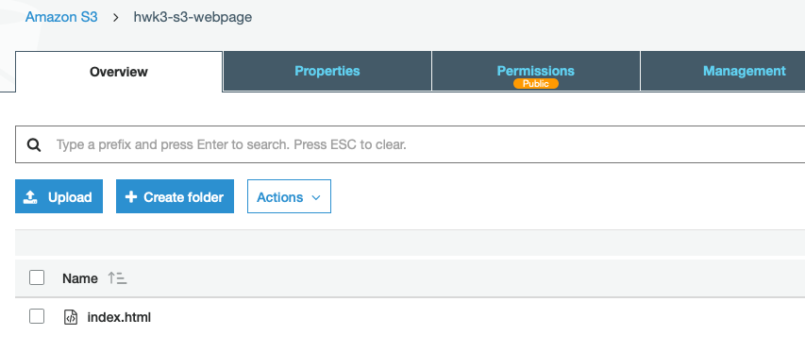

1. The S3 bucket policy was setup as public with the policy shown below

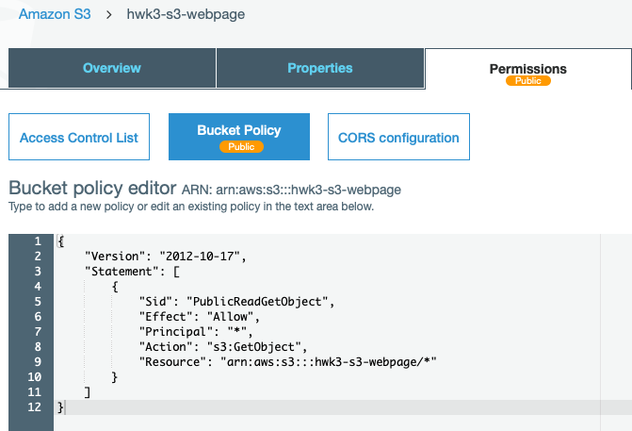

1. The site was checked and it works. The site URL is <http://hwk3-s3-webpage.s3-website-us-west-1.amazonaws.com>

**Problem 2**

1. An instance with AWS Linux AMI was bootstrapped with the user data below and created in the public subnet created in homework 2. The ssh keys and new user implementation are also included in user data. Apache HTTP server was installed with the line “Assignment 3: Public Web Server” as also show below

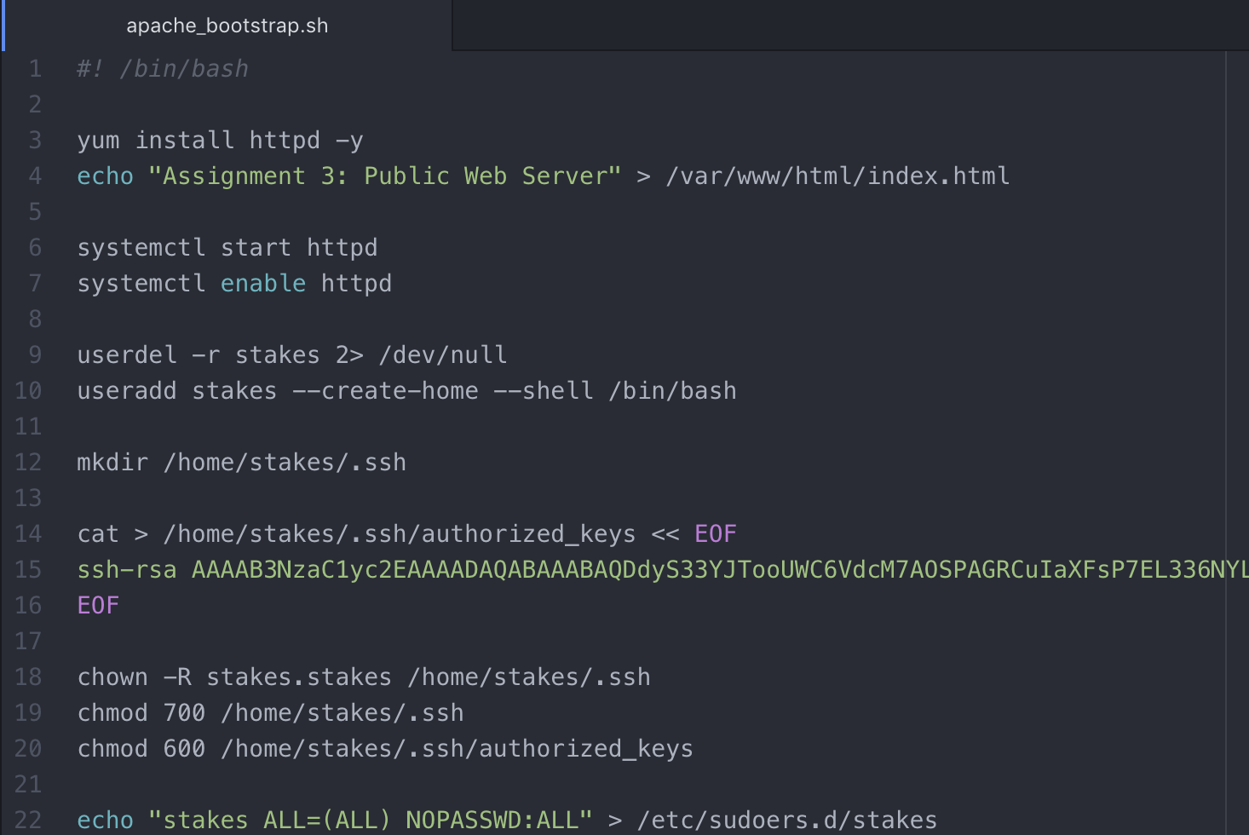

The EC2 instance(hwk3_vpc1_pub) was created and running

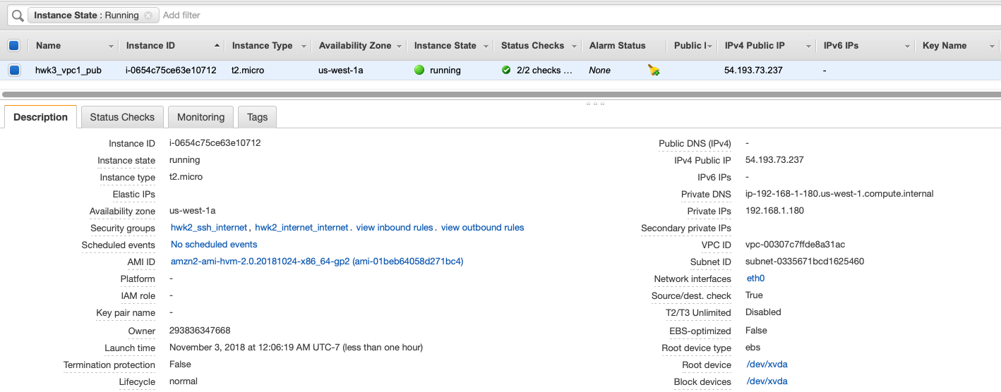

The webpage was checked and the apache server was running



**Note:** the assignment 2 private subnet was replaced with a new subnet in AZ **us-west-1b**

While the public subnet remained in AZ **us-west-1a**. Thus, having two availability zones in the original VPC

The same above steps was used to create another instance in the private subnet in different AZ. The private instance apache server is only serving “Assignment 3: private Web Server”. The instance was launched and it was working as shown below,

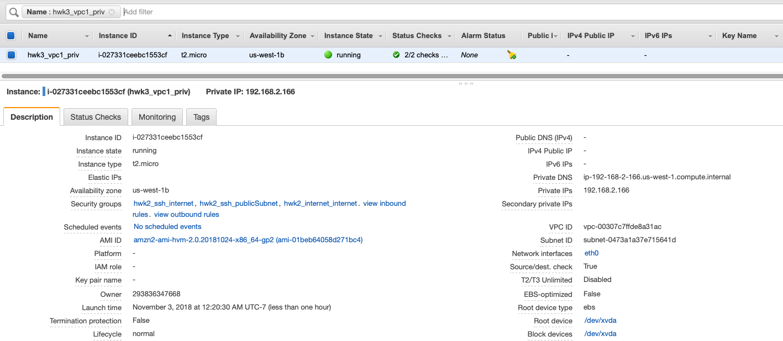

Using ssh access to the public instance, the private server was verified as working



7) The network load balancer created using the application load balancer. It was placed in the HW2 VPC with Web port 80 open to incoming traffic. **DNS Name is hwk-NLB-718786712.us-west-1.elb.amazonaws.com**

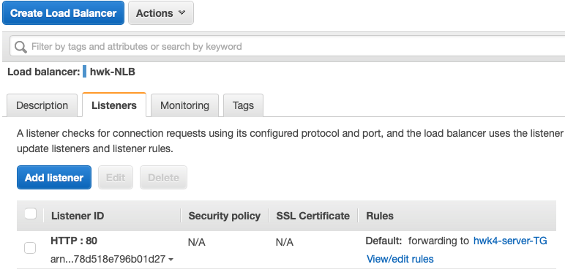

The target group was also created as described in the instruction manual including the recently created public and private instances as its registered targets,

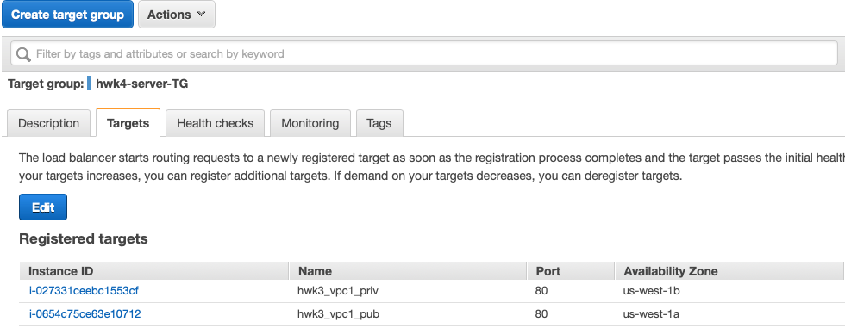

**Loading details**

To confirm that the load balancer/target group setup works, a custom load balancing script was written. The load balancer IP address was recovered using

***“host <dns name>”***

With the IP address, my VM sends multi-process looped http requests to the load balancer’s resolved IP via the “curl” command. **I could not get JMeter to work so I improvised.** The looped commands per process is shown below

***curl -s*** [***http://54.193.86.88:80?[1-1000]***](http://54.193.86.88:80?[1-1000])

The result shows both machines responding to the load balancer’s http requests

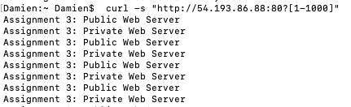

When the load goes up, the DNS name resolves to more IP addresses.

**Problem 3**

1. As specified by the instruction manual, the launch configuration and Auto Scaling were created as directed as shown below,

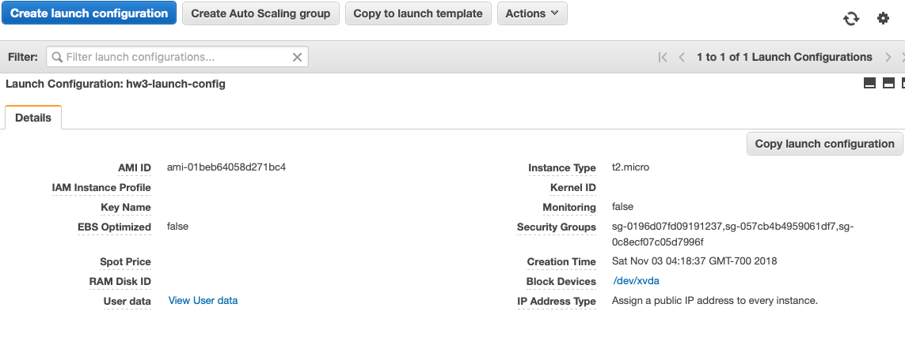

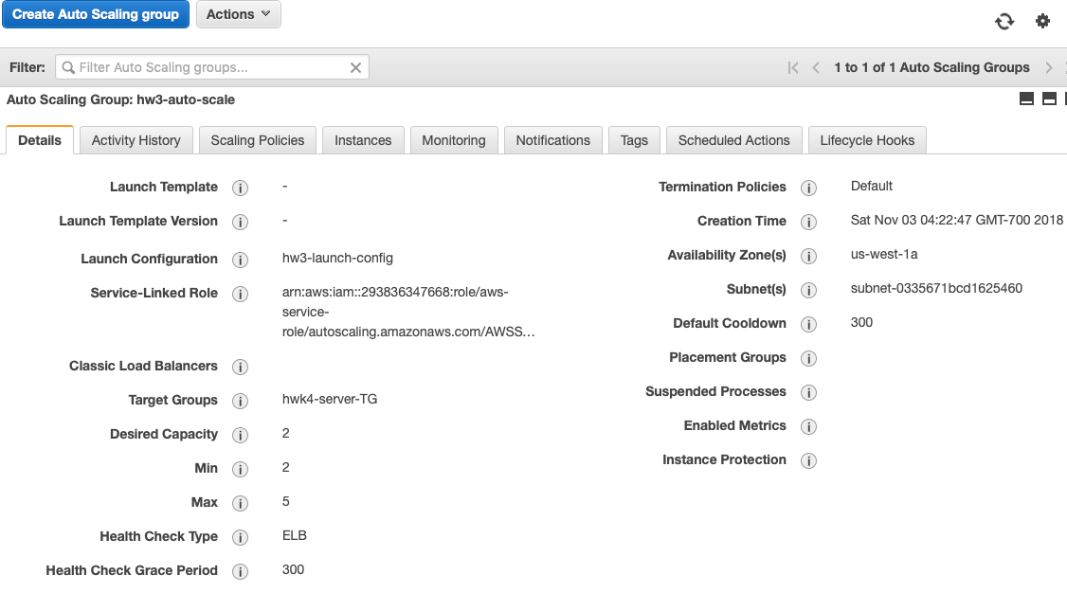

* 1. As instructed by the instruction manual, auto scaling starts with 2 instances. When one stance was terminated, the site did not go down because the second instance was still running. The site only goes down when both instances are terminated. After the single instance termination, the instance was immediately deleted form the target group as shown below.

Two auto scale instances are running fine

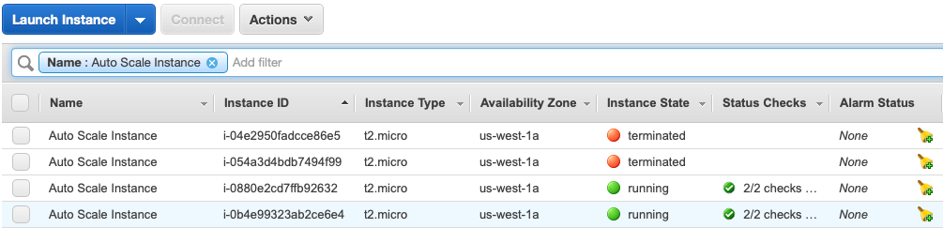

Target group shows both running instances as healthy

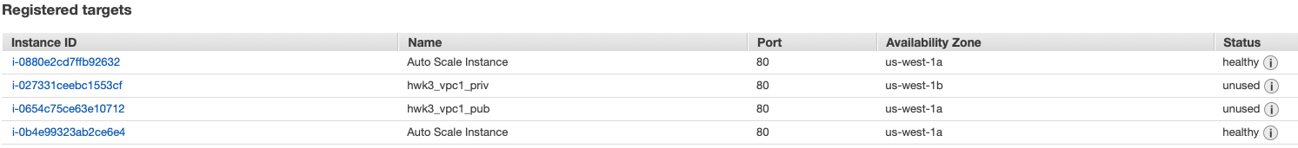

Then, one instance was terminated

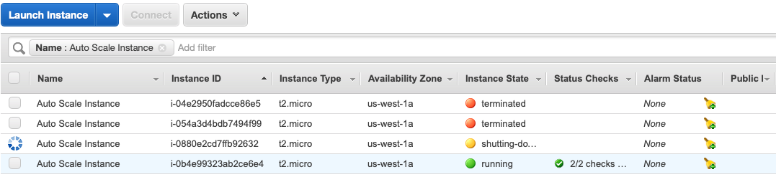

The target group instantly deleted the terminated instance

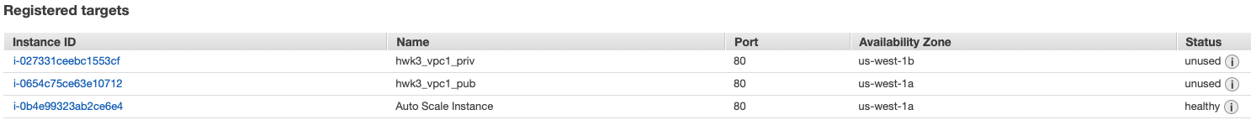

* 1. The autoscaling immediately created another instance in its place and the website is now accessible from both instances

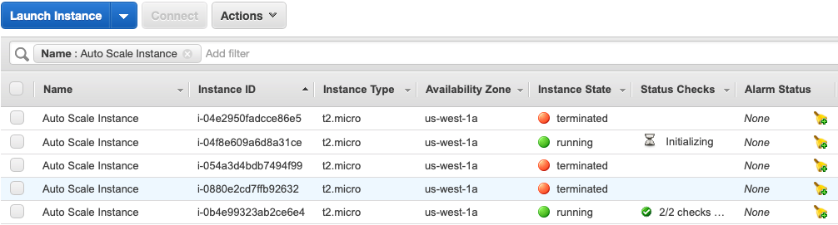

1. The Load was applied and an additional instance was created indicating that the 35% CPU load had been met by both load balancer target group instances

**Problem 4:**

1. The “dev” branch assignment 2 folder merging to “master” branch is shown below



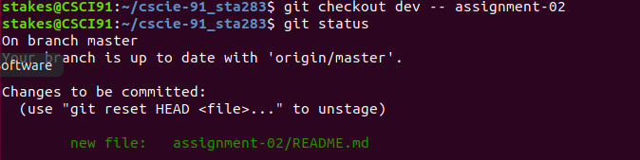

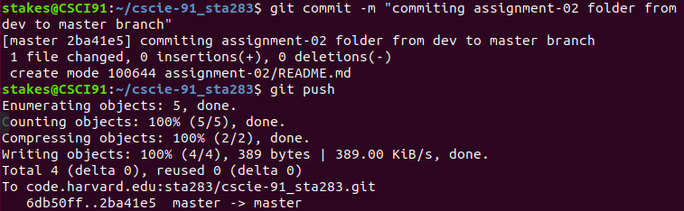

1. The assignment 3 folder was created in “dev” and the documentation text file ( assig3_quest3_doc.txt) was added to the assignment 3 folder and pushed to code.harvard.edu (link: <https://code.harvard.edu/sta283/cscie-91_sta283/blob/dev/assignment-03/assig3_quest3_doc.txt>). The documentation file also contains as URL that helps demonstrate the relationship between autoscaling and load balancers. A screenshot of the text pushed assignment 3 folder and text file is shown below,

